Title of the Presentation for ICFM 2024
(Times New Roman 14 pt Bold)
Presenting Author, Author2, Author 3, *Corresponding Author
(12 pt Bold and underline presenting author and asterisk corresponding author)
¹Affiliated Institution Name, Address (12 pt italic)
²Additional Affiliated Institution Name, Address
*Corresponding Author: Name and E-mail Address (Times New Roman 12 pt Bold)
The abstract should be written using 12-point Times New Roman font and summarize the technical content of the oral or poster presentation. Use single spacing throughout. The page margins should be 3 cm (1.18”) on all sides for a standard A4 page (21x 29.4 cm). The abstract should be limited to 250 words and the text body should be justified on both sides. The abstract,
inclusive of any figures, tables or references, should not exceed one (1) standard A4 page. Any abstract that does not follow the abovementioned guidelines will be rejected.
All submitted abstracts will be reviewed according to the standard reviewing procedures and assigned by the technical program committee to the appropriate session for oral and poster presentations.
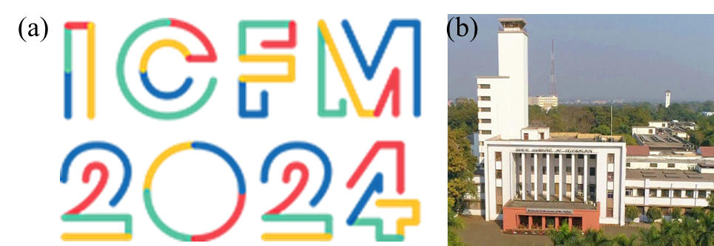
Figure (a) International Conference on Functional Materials, and (b) organized by the Materials Science Centre at IIT Kharagpur.
In order to submit your abstract, please go to the ICFM2024 website and create an account.
Once you do this, you can then submit your abstract online via the website.

Keywords: Provide a maximum of five keywords.
Reference: P. Sahoo et al. Title of the paper, Journal Name, Vol. (Year) Page no.

